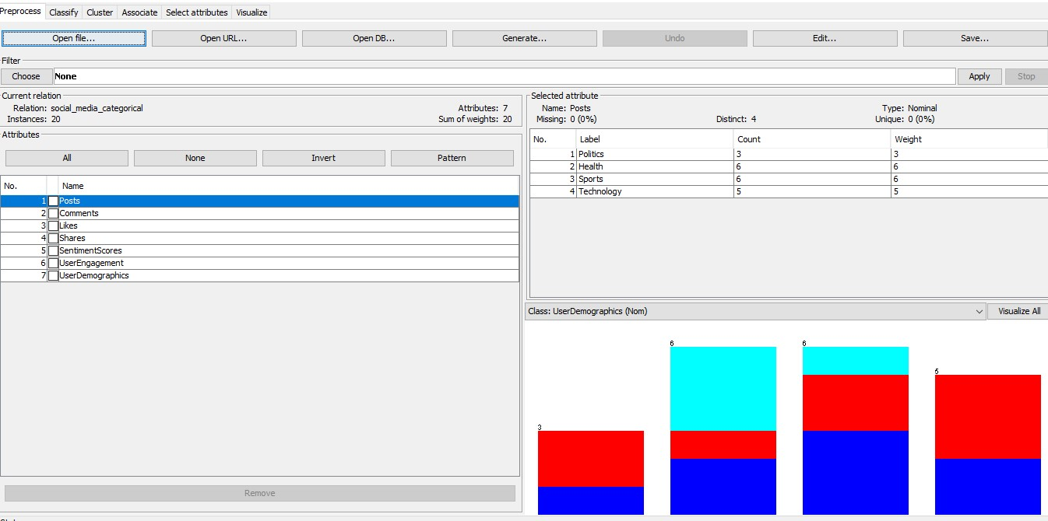

Association Mining in Weka

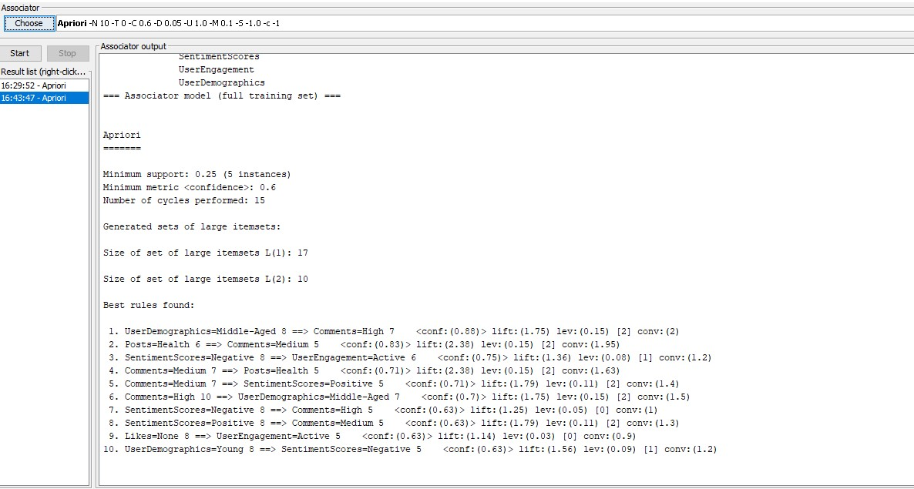

**Analysing Results**

Observations from the patterns

1. Middle-aged users are highly engaged

The Rule is: UserDemographics = Middle-Aged → Comments = High

Middle-aged users tend to comment more actively than other demographics.

1. Health-Related Posts Attract Moderate Engagement

The Rule: Posts = Health → Comments = Medium

1. Negative Sentiment Drives Higher Engagement

The Rule: SentimentScores = Negative → UserEngagement = Active

Users are **more likely to interact with content** that sparks controversy or raises concerns.

1. Medium Engagement Often Leads to Positive Sentiment

The Rule: Comments = Medium → SentimentScores = Positive

When engagement is moderate (not extreme), **sentiment is more likely to be positive.**

****Cluster Analysis****

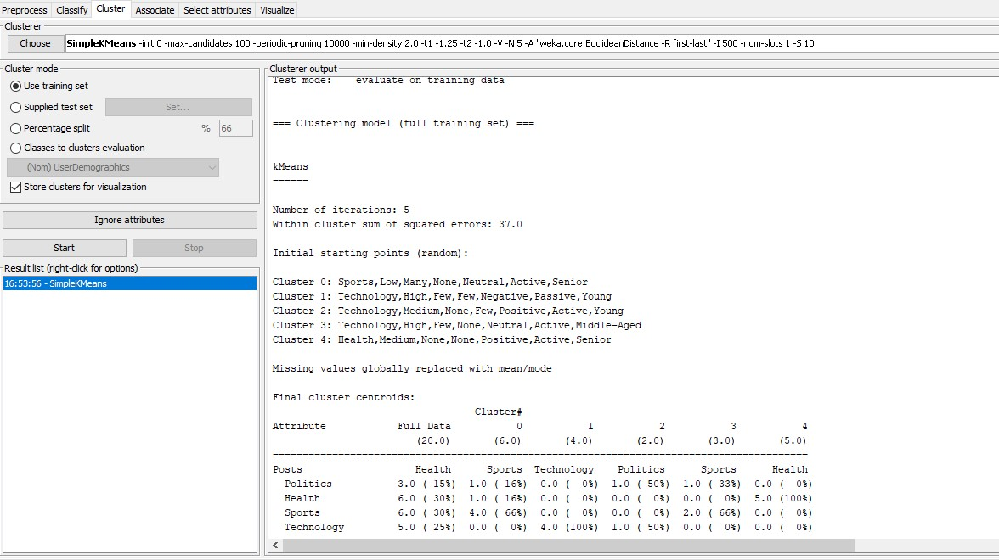

Results

Each cluster represents a different type of user, helping understand their political behavior:

**Cluster 0 (Passive Observers - Sports Fans)**

Engage with **sports-related posts**, **like content** but don’t **comment or share much**.

Strategy: **Encourage engagement with interactive content (polls, Q&A sessions).**

**Cluster 1 (Skeptical Technology Users - Critical Analysts)**

Focused on **technology discussions**, **high commenting activity**, but **negative sentiment**.

Strategy: **Use fact-based responses to counter skepticism & misinformation.**

**Cluster 2 (Young Active Discussants - Political & Tech Enthusiasts)**

Highly engaged, frequently comment on **political and technology content** with **positive sentiment**.

Strategy: **Leverage their engagement for discussions, mobilize them for online activism.**

**Cluster 3 (Middle-Aged Negative Sharers - Sports Debaters)**

Frequently engage in **sports discussions**, high sharing, but **negative sentiment**.

Strategy: **Use positive storytelling & rebuttals to counter misinformation.**

**Cluster 4 (Senior Health Advocates - Passive Supporters)**

Engage mostly with **health-related content**, have **positive sentiment**, but don’t share much.

Strategy: **Encourage community-building by sharing success stories & testimonials.**

****Model Evaluation****

**Support:**

Minimum **5 instances** (out of 20 total transactions).

This means each rule applies to at least 25% of the dataset.

**Confidence:**

Minimum **0.6 (60%)**, meaning rules are **highly reliable** in predicting the consequence.

**Lift:**

Measures how much more likely the consequence is, compared to random chance. Lift **>**1 indicates a useful rule.

**Visualization**

